PRE-AUTHORIZED DEBIT (PAD)
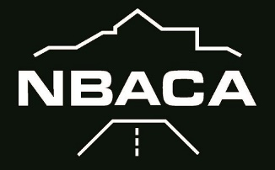
- Customer Information (please print clearly):

Northumberland Builders and Construction Association Inc.
3-21 King St. W
Cobourg, ON K9A 2M1
PH: 289.252.6159
www.NBACA.ca

Name: ______________________________________________________________________________

Mailing Address: _______________________________________________________________________________

City: _______________ Province:_____________ Postal Code: _________________

Telephone Number: _____________________ E-mail Address: ______________________________________
- Bank Account Information:
Financial Institution Number (3 Digits): ____________ Financial Institution Name: ________________________________
Financial Institution Branch Address: ______________________________________________________________

Deposit Account Number: _____________________________

Branch Transit Number: _______________________________ Chequing Account: Savings Account:

- Pre-Authorized Debit (PAD) Details

You, the Payor, authorize NBACA to debit the bank account identified above for $45.00 per month. The debit will be processed on the first business day of the month.
These services are for (check one) ______personal _X_business use

You, the Payor, may revoke your authorization at any time, subject to providing notice of 30 days. To obtain a sample cancellation form, or for more information on your right to cancel a PAD Agreement, contact your financial institution or visit www.payments.ca.

Signature of Account Holder: Signature of Joint Account Holder: (if applicable)

__________________________________ ______________________________________

Name: ____________________________ Name: ________________________________
(Please print) (Please print)

Date: _____________________________ Date: ________________________________

You have certain recourse rights if any debit does not comply with this agreement. For example, you have the right to receive reimbursement for any debit that is not authorized or is not consistent with this PAD Agreement. To obtain more information on your recourse rights, contact your financial institution or visit www.payments.ca

